DATA PRODUK

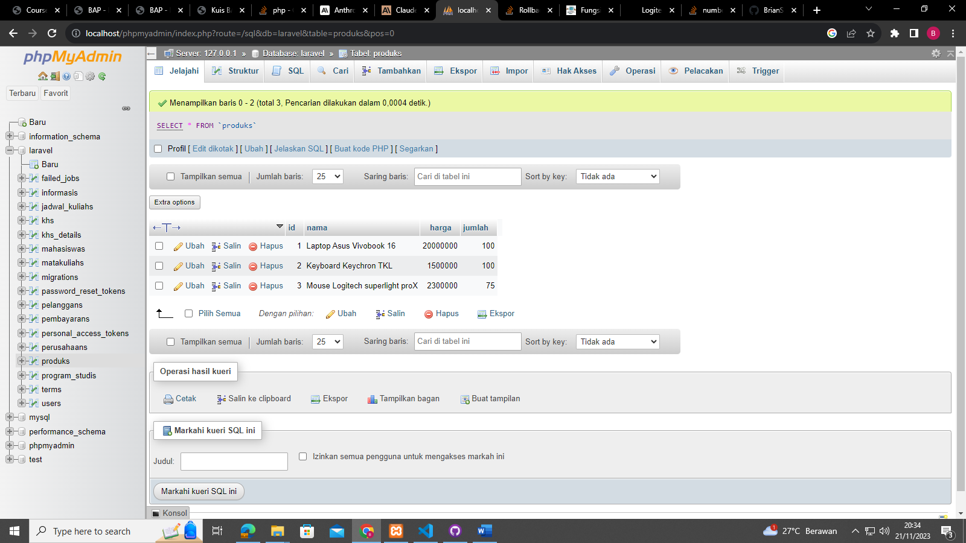

DATA PELANGGAN

DATA PERUSAHAAN

